Order Of Lenten Service

Opening Hymn: TLH 159

Reading: Lent VI

The History of the Passion of our Lord

Sermon Hymn: TLH 436

Sermon Text: Song Of Solomon 6:1-2

Question & Answer

Prayer

Holy Communion

The Lord's Prayer

The Blessing

Closing Hymn: TLH 179

* * * * * * * * * * * * *

Koinonia Hour

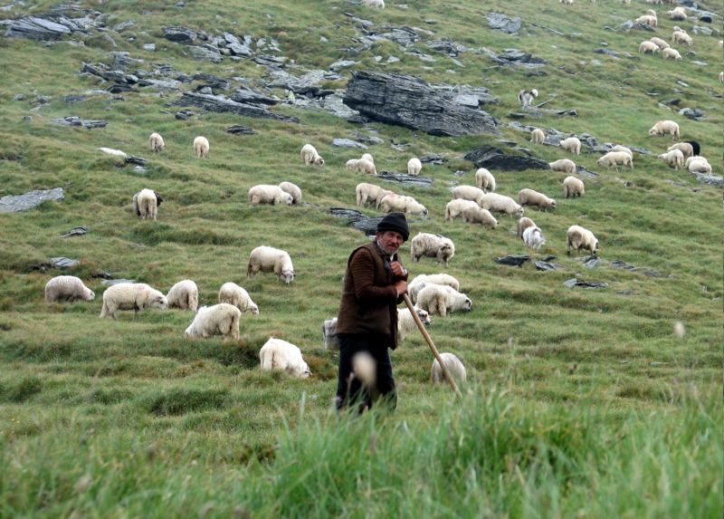

Feeding The Flock

Water
Of
Life

2 April 2017

W A T E R O F L I F E

Independent Christian Church—Conservative Lutheran Doctrine

Worship Service: 9:30 a.m. Bible Study: 10:45 a.m.

Larry Cooper, Pastor E-Mail address:
111 N. Ridge Road lcooper@wateroflife.cc
Coon Valley, WI 54623 Web Site:
Phone: (608) 452-2105 www.wateroflife.cc

* * * * * * * * * * * * * * * * * * * * * * * * * * *

Sermon Text: Song Of Solomon 6:1-2

Question & Answer

* * * * * * * * * * * * * * * * * * * * * * * * * * *

Song of Solomon 6:1 Whither is thy beloved gone, O thou fairest among women? whither is thy beloved turned aside? that we may seek him with thee.
:2 My beloved is gone down into his garden, to the beds of spices, to feed in the gardens, and to gather lilies.

The Garden of Eden—Genesis 2:7-9

7 And the LORD God formed man of the dust of the ground, and breathed into his nostrils the breath of life; and man became a living soul.
8 And the LORD God planted a garden eastward in Eden; and there he put the man whom he had formed.
9 And out of the ground made the LORD God to grow every tree that is pleasant to the sight, and good for food; the tree of life also in the midst of the garden, and the tree of knowledge of good and evil.



The Garden of Gethsemane—John 18:1-3

1 When Jesus had spoken these words, he went forth with his disciples over the brook Cedron, where was a garden, into the which he entered, and his disciples.
2 And Judas also, which betrayed him, knew the place: for Jesus ofttimes resorted thither with his disciples.
3 Judas then, having received a band of men and officers from the chief priests and Pharisees, cometh thither with lanterns and torches and weapons.

